The Islamia University of Bahawalpur
Department of Information Technology


SOFTWARE DESIGN DISCRIPTION
Dental Management System

Submitted By: Tarana Bashir
Roll No: F22BINFT1E02143

Session Fall 2022 – 2026
Supervisor
Ms. Kainat
Bachelor of Science in Information Technology

Table of Contents
The following Software Requirements Specification has been accepted and approved by the following:

- INTRODUCTION. 1
  - Purpose. 1
  - Scope. 1
  - Overview 1
  - Reference Material. 2
  - Definitions and Acronyms 3
- SYSTEM OVERVIEW 3
- SYSTEM ARCHITECTURE 5
  - Architectural Design 5
  - Decomposition
Description 5
  - Design Rationale...................................................................................................................................... .............
- DATA DESIGN. 10
  - Data Description 10
  - Data Dictionary 13
- COMPONENT DESIGN. 17
- HUMAN INTERFACE DESIGN. 26
  - Overview of User Interface. 26
  - Screen
Images 27
  - Screen Objects and Actions.................................................................................................................. ................
- REQUIREMENTS MATRIX. 29
- APPENDICES. 32




INTRODUCTION

Purpose
A Dental Health Management System (DHMS) is a comprehensive and advanced web based platform that is designed to help dental professionals manage and organize their practice more efficiently. It includes a wide range of features and functionalities that are specifically tailored to meet the needs of dental professionals.
The introduction of a DHMS website would typically provide a detailed overview of the system and its capabilities, including information on the various modules and tools that are included. This would likely include information on appointment scheduling, electronic health records, treatment planning, and patient communication tools. Additionally, the introduction would likely include information on how to access and use the platform, as well as any relevant technical details, such as supported browsers or operating systems.
The website may also include testimonials from satisfied dental professionals and patients who have used the system. This can be very helpful in providing potential users with an understanding of the real-world benefits and advantages of the DHMS.
Furthermore, the website may also have a section dedicated to the support and training, where the users can find information on how to troubleshoot issues, and how to access online tutorials or training materials to improve their knowledge of the system.
In summary, the introduction of a DHMS website would typically provide comprehensive information on the system's capabilities, how to access and use the platform, testimonials from satisfied users, and support and training resources.

Scope
An online dental health management system can have a broad scope and can cover various aspects of dental health management. Here are some of the areas that an online dental health management system can cover:
Appointment scheduling: The system can allow patients to schedule their dental appointments online and manage their appointments according to their availability.

Patient records: The system can maintain digital records of patients, including their personal details, medical history, treatment plans, and progress.
Treatment plans: The system can assist dentists in creating customized treatment plans for each patient and track the progress of the treatment.
Communication: The system can facilitate communication between dentists and patients, allowing them to ask questions, share information, and receive advice.
Billing and payment: The system can manage billing and payment for dental services, making it easier for patients to pay for their treatments.
Education: The system can provide patients with educational resources and information about dental health, such as oral hygiene practices, dental care tips, and preventive measures.
Overall, an online dental health management system can provide a convenient and efficient way to manage dental health for both patients and dentists.

Overview
First section contains introduction of the project, second section of SDD contain system overview this section describe the overall definition in a high level manner. Third section contains system architecture of the project main components and its subcomponents are define in section in three. Four sections contain Data Design. In this section the system using Entity Relationship Diagram and Data Flow Diagram etc. Section Five contains component design, in which different comments are design. Section six of the SDD customers implementing the design interface and the last section contains the requirements matrix.

Reference Material Google.com Google scholar

Definitions and Acronyms

ODHMS Online Dental Health Management System

SDD System Design Description HTML Hyper Text Markup Language CSS Cascading Style Sheet
UML Unified Modeling Language
PHP HypertextPreprocessor

- SYSTEM OVERVIEW

Technology
Different technologies used in Online Dental Health Management System these are HTML, CSS, PHP, JavaScript, MYSQL. HTML, CSS and Bootstrap used to make front end of the system interacting. JavaScript, MYSQL and PHP are used at back-end of the system to perform functionalities. MYSQL database used to store data like online shop detail’s user’s information like email, password, registration, login and product information of user. PHP used to communicate with the user of the system point of view.
General Constraints: This system will be completed by using MY SQL relational database. Developer of the system requires local web server for testing to include Apache web server 2.0, PHP 5.0, My SQL 5.or higher.
Design Consideration: MY SQL database should also be installed in the system.

Application Overview
An online dental health management system is a software platform that provides digital tools to manage various aspects of dental health. It is designed to streamline dental practice management, improve patient outcomes, and enhance patient engagement.
Some of the key features of an online dental health management system include: Electronic health records (EHRs): The system can store and manage patient information,
including medical history, treatment plans, X-rays, and other diagnostic tests.

Appointment scheduling: The system can allow patients to schedule appointments online, view available time slots, and receive reminders via email or text.

Treatment planning: The system can assist dentists in creating customized treatment plans for each patient, tracking progress, and providing real-time updates.
Communication: The system can facilitate communication between patients and dentists, allowing them to ask questions, share information, and receive advice.
Billing and payment: The system can manage billing and payment for dental services, including insurance claims, co-payments, and payment plans.
Education and engagement: The system can provide patients with educational resources and tools to promote good oral hygiene and preventive care, and to increase patient engagement.
The benefits of an online dental health management system include improved patient outcomes, enhanced patient satisfaction, reduced administrative burdens, increased practice efficiency, and improved revenue management. Overall, an online dental health management system can help dentists deliver better patient care and improve the overall health of their patients.

System Requirement
The application is designed to work on all the operating systems that can support a current media enabled to web browser.

Design Language
UML (unified modeling language) used to indicate the design of any system. Entity Relationship diagram, Data Flow Diagrams, Class Diagrams, Activity Diagrams, Sequence Diagrams and State Machine Diagrams also used during development of Online Fresh Fruits and Vegetables Shop system. These all diagram indicate the design of online dental health management system.

System Environment
The application is designed to work on all operating systems having the latest web browsers. The OHRS system is accessible through any Laptop desktop Tablets Smartphone that will be connected to the server.

SYSTEM ARCHITECTURE

Architectural Design
In Online Dental Health Management System user that is registered by filling “signup” form will have more rights as compare to visitors. User can search Doctors and make an appointment and visit the site without login. Registered user give feedback and feedback receive by administrator. Record of registered user store in database. All records are updated by database.

Web Architecture
The user represents the computers or other devices used to access the application. The middle phase comprises with the server. The server consists of back-end applications to handle different tasks. End phase consists of storage sub-systems mainly the database. These phases communicate using formal protocols like TCP/IP. The server through a database connector handles all database requests from client side to the database, as well as response is controlled by the server.

Internet Web Application

Database
Web Server

Web Architecture for Online Dental Health Management System

Block Diagram

User
User
User
User
User
User

Web Server
Web Application

Database
Login
Registration
Update Details

Block Diagram for Online Fresh Fruits and Vegetables Shop System

  - Decomposition Description

Registration procedure is used to register new customer log is used to access his/her account. Only Register users will be able to log in later, because only those people login, who have their registered account. Payment class is used to store data about the payment details. User also comments below the images or share the, only register user shares the images on specific social site like Face book etc. Users may also able to send their feedback about the site and contact with admin to purchase products. For a functional description, put top level data flow diagram (DFD) and structural decomposition diagrams.

Use Cases

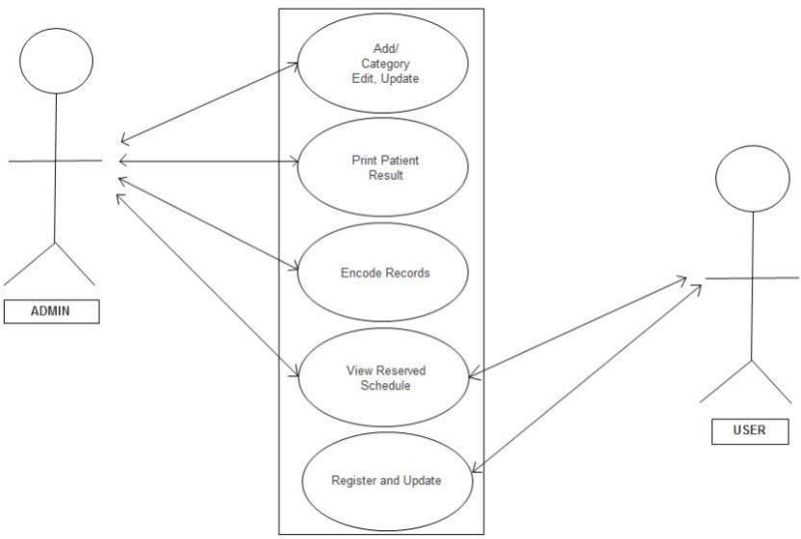

Actor | Customer
Description | Customers see the different categories of Drs.
Pre-condition | Customers want to see the different categories of Drs.
Steps | Customers select the categories list and see different Drs on the list.
Post-condition | Customers successfully view the category list.
  - Sequence Diagrams
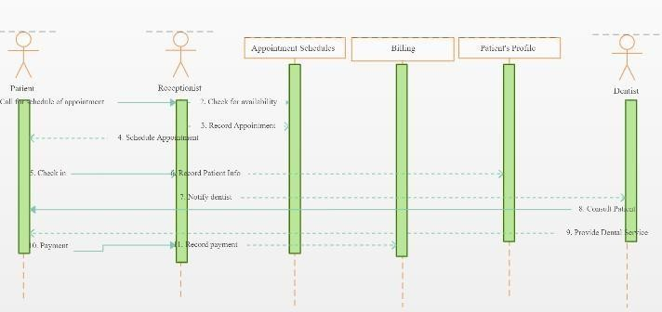

3.4 Class Diagrams
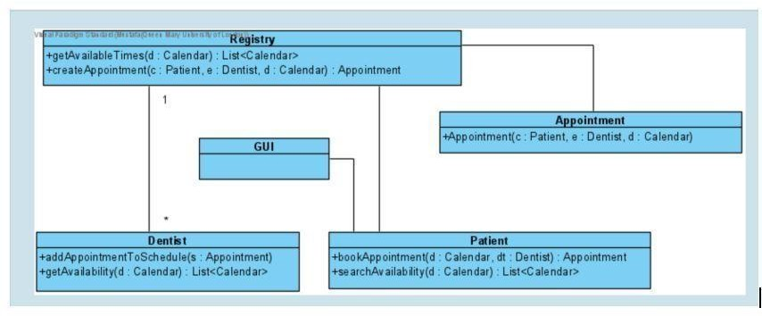

3.5 Data Flow Diagram
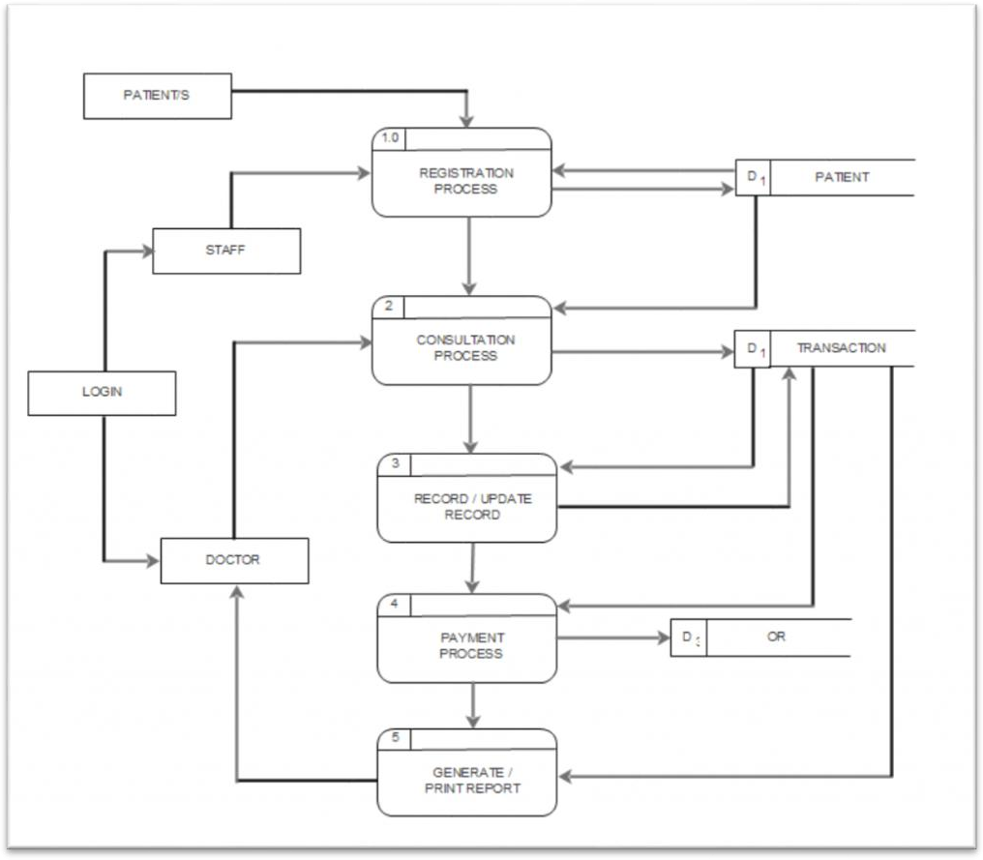

- DATA DESIGN

Data Description
MYSQL database is used for storing information of online Dental Health Management System script is used for manipulating data, getting the data and place data in MYSQL database.
    - Administrator

Attributes | Description
Id | Describe id of the Admin to uniquely identify the Admin of the site.
Name | Describe name of the admin.
Password | Describe password of the admin.
Email-Id | Describe email of the admin.
Gender | Describe gender of the admin.
Address | Describe address of the admin.
Phone Number | Describe the phone number of the admin.
    - Customer

Attributes | Description
Id | Describe Id of the Customer to uniquely identify the Customer.
Name | Describe name of the customer.
Password | Describe password of the customer.
Phone Number | Describe phone number of the customer.
Email | Describe email of the customer.
Address | Describe address of the customer.
Credit Card- Info | Describe the credit card information to the customer.
    - Database Class

User Name | Describe the name of the customer.
Password | Describe password to the customer.
Database Name | MYSQL.

PHP Address | Describe the PHP address to the customer.
Insert Record | Users easily insert the record.
Delete Record | Users delete the record.
Update Record | Users update the record.
Fetch Record | Users fetch the record.
    - Feedback

Attributes | Description
Feedback id | Describe id of the feedback.
User Id | Describe the user id.
Feedback Type | Describe type of the feedback.
Feedback Title | Describe the title of the feedback.
Email-id | Describe the email-id of the shop system.
Comments | Write comment about site of the services.
    - Login Credential

Attributes | Description
Customer Name | Describe name of the customer.
Password | Describe password of the customer.
Permission | Give permission to customer to login.
Phone number | Describe phone number of the customer.
Email- Id | Describe email- id of the customer.
    - Registration

Attributes | Description
Customer name | Describe the name of the customer.
User name | Describe the name of the user.
Password | Describe the password of customer and user.

Postal address | Describe the postal address of customer.
Email-Id | Describe the email-id of customer and user.
Hobby | Describe the hobbies of customer and user.
Phone Number | Describe the phone number of customer and user.
Gender | Describe the gender of user and customer.

Data Dictionary
    - Administrator

Parameters: | Parameter Type:
Id: | Integer
Name: | String
Password: | String
Email-Id: | Integer
Gender: | Character
Address: | String
    - Customer

Parameters: | Parameter Type:
Id: | String
Name: | Char
Password: | String
Phone Number: | Integer
Email: | String
Address: | String
Credit Card- Info: | String
    - Database Class

Parameters: | Parameters Type:
User Name: | Char
Password: | String

Database Name: | Char
Insert Record: | String
Delete Record: | String
Update Record: | String
Fetch Record: | String
    - Feedback

Parameters: | Parameter Type:
Feedback -Id: | String
User Id: | String
Feedback Type: | Char
Feedback Title: | String
Email-Id: | String
Comments: | String
    - Login Credential

Parameters: | Parameter Type:
Customer Name: | Char
Password: | String
Permission: | Char
Phone number: | Integer
Email- Id: | String
    - Registration

Parameters: | Parameter Type:
Customer name: | Char
User name: | Char
Password: | Integer
Postal address: | Char
Email-Id: | String

Hobby: | String
Phone Number: | Integer
Gender: | Char
1.3 ER Diagram of “Online Dental Health Management System”
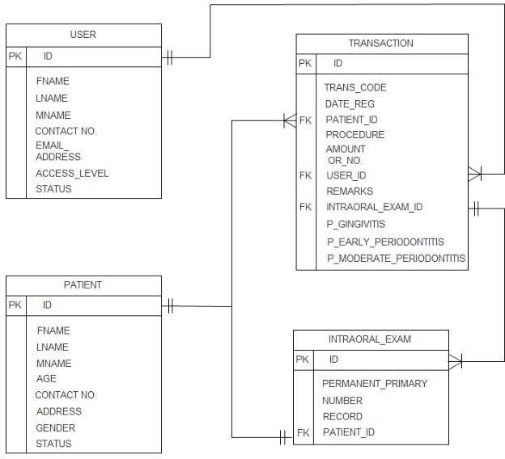

2. COMPONENT DESIGN

1.1 Registration
Class Name:Registration
Brief Description:Registration class used to explain the attributes and methods that help to register user at online dental health management system by getting different information about user and customer. User Name, Hobby, Email, Password, Phone No, gender and address.
Attributes(Fields) | Attributes Description
User name: string | Describe the name of the user.
Hobby: string | Describe the hobbies of the user.

Password: string | Describe the password of customer and user.
Address: string | Describe the postal address of customer.
Email: string | Describe the email of customer and user.
Phone number: string | Describe the phone number of customer and user.

Gender: character | Describe the gender of user and customer.
Methods | Methods Description
createAccount() | createAccount() method is used to create account of user and customer.
 | Pseudo Code
- User and Customer enter the name, email, password, gender and address.
- Validation of account form is performed if User and Customer fill all necessary information
Show “successfully created user account”.
Else
- If any field is missing from necessary information Show “fill all necessary fields.”
- Database connection is created.
- User and Customer information is stored in database.
deleteAccount() | deleteAccount() method is used to delete account of user and customer.
 | Pseudo Code
- Database connection is created.
- Verify if User and Customer information is stored in database.
- If there is any information found in database then delete it Show message “successfully account is deleted.”
- Information of user and customer is deleted from database.
updateAccount() | updateAccount() method is used to update account of user and customer.

 | Pseudo Code
- Database connection is created.
- User and customer enter the information in the database.
- If any information is not found or user and customer want to add more information in database, then user and customer update
its account.
Show message “successfully account is updated”.
registerCustomer() | Customer use customerRegistration() function for registration.
 | Pseudo Code
- Database connection is created.
- Customer enters all necessary information.
- Show message “Customer is registered”.
- Show message “successfully customer is registered in the Database”.
  - Login Credential
Class Name: Login Credentials
Brief Description:Login Credential class explains all attributes and methods that help in login of user. User have to enter his/her email, password to login and phone number is required to set forget password and for reset password. Any user can login and logout.
Attributes(Fields) | Attributes Description
Customer Name: String | Describe the name of the customer.
Password: String | Describe the password of customer.
Permission: String | Give permission to user to login.
Email id: String | Describe the email of user.
Phone Number: String | Describe the phone number of user.
Methods | Methods Description
login() | login() method used to get access after login in user account.
 | Pseudo Code

- Only user login that must be registered.
- For login user enter name and email.
- Database connection is created.
- Verify information from MY SQL database.
- if information Verify Show “login successfully.”
- Else if information is not correct Show “Enter correct information.”
- Display website page after login “successfully.”
forgetPassword() | forgetPassword() method used to set new password when user forget his account password.
 | Pseudo Code
- Database connection is created.
- If user forget password
Show “Enter your phone number.”
- If phone number is matched Show “set your new password” Else
Show “enter your correct password.”
resetPassword() | resetPassword() method to set new password when user have to know his current password.
 | Pseudo Code
- User must know his/her previous password.
- Database connection is created.
- Enter his/her previous password. 4.Validation is performed
If previous password match with store password, then Show “reset password”
Else
Show “enter correct previous password ”
logout() | logout() method used to end session of access.
 | Pseudo Code

- Database connection is created.
- User click logout button for logout.
  - Customer

Class Name: Customer
Brief Description: Customer class used to explain all the attributes and methods that define all the activities of customer.
Attributes(Fields) | Attributes Description
Customer name:  string | Describe the name of the customer.
Address: String | Describe the address of the customer.
Email: String | Describe the email of the customer.
Credit card information:  string | Describe the credit card information of the customer.
Phone Number: String | Describe the phone number of the customer.
Gender: Character | Describe the gender of the customer.
Methods | Methods Description
login() | login() method used to get access after login- in customer account.
 | Pseudo Code
- Only customer login that must be registered.
- For login customer enter name and email.
- Database connection is created.
- Verify information from MY SQL database.
- If information Verify
Show “login successfully.”
  - Else if information is not correct. Show “Enter correct information.”
  - Display website page after login “successfully.”
registration() | Customer registration() function for registration.
 | Pseudo Code

- Customer enters name, id, email, phone number Password, gender and address.
- Validation of account form is performed if User fill all necessary information
show “successfully registered.”
- Else if any field is missing from necessary show “not successfully registered.”
- Database connection is created.
- All user information stored in database.
visitWebsites() | User can use visitWebsites() function to visit all the websites.
 | Pseudo Code
- Database connection is created.
- Customer enter required product in search bar. 3.Validation is performed
4.If search product match with any product that store in database than
Show message “customer can view product detail”.
registerComplaint() | User can use registerComplaint() function to Make complaint regarding order.
 | Pseudo Code
- Database connection is created.
- User can login in database to make complaint about order.
- After making complaint user logout from database.
logout() | logout() method used to end session of access.
 | Pseudo Code
- Database connection is created.
- click logout button for logout.
  - Administrator
Class Name: Administrator

Brief Description:Admin manage this website by using attributes and perform different functions. Attributes are admin name, phone number, address,email and gender. Admin can perform different functions to manage this website these are adding new Drs detail, delete old drs detail, update detail and update profile, sent email and logout.
Attributes(Fields) | Attributes Description
Admin id: Integer | Describe the id of admin.
Name: String | Describe the name of the admin.
Password: String | Describe the password of the admin.
Address: String | Describe the address of the admin.
Email id: String | Describe the email of the admin.
Phone Number: String | Describe the phone number of the admin.
Gender: Character | Describe the Gender of the admin.
Methods | Methods Description
login() | login() method used to get access after login- in user account.
 | Pseudo Code
- Only admin login that must be registered.
- For login admin enter name and email.
- Database connection is created.
- Verify information from MY SQL database.
- If information Verify
Show “login successfully.”
- Else if information is not correct Show “Enter correct information.”
- Display website page after login “successfully”
addProductDetail() | addProductDetail() function used admin for add product detail.
 | Pseudo Code
- Database connection is created.
- If new products are available than Show “Admin add product detail”
- If products add

 | Show “products detail added successfully.”
deleteProductDetail() | deleteProductDetail() function used for delete product detail.
 | Pseudo Code
- Database connection is created.
- If products are unavailable than. Show “Admin delete product detail.”
- If products delete
Show “product detail delete successfully.”
updateProductDetail() | updateProductDetail() function used for update product detail.
 | Pseudo Code
- Database connection is created.
- If products are available than
Show “Admin modify product detail.”
- If products modify
Show “product detail update successfully.”
updateProfile() | updateProfile() function used for update profile.
 | Pseudo Code
- Database Connection is created.
- Admin click update profile button to update profile.
sentEmail() | sentEmail() function is used for sent email to customer.
 | Pseudo Code
- Database Connection is created.
- Admin login to the database to send email to customer for every new updates regarding system.
- Admin logout from database.
logout() | logout() method used to end session of access.
 | Pseudo Code
- Database connection is created.
- Admin click logout button for logout.
  - Feedback

Class Name:Feedback
Brief Description: Feedback is commenting that give user after using this website. Admin take feedback and give response to the customer. By using this comment web site can be made better for the customer of this website.
Attributes(Fields) | Attributes Description
Feedback id: Integer | Describe id of the feedback.
Feedback type: string | Describe type of the feedback.
Email id: Integer | Describe the email-id of the store.
Comment: Varchar | Write comment about site of the services.
Methods | Methods Description
giveFeedback() | giveFeedback() method used customer to give feedback.
 | Pseudo Code
- Database connection is created.
- Costomer give feedback.
- Feedback dialog box open.
- If dialog box open successfully Show “enter comment.”
Else
Show “error in database connection.”
showFeedback() | showFeedback() method is used to view the user comment.
 | Pseudo Code
- Database connection is created.
- Click on view feedback.
- If feedback dialog box open
Show “open dialog box successfully” Else
Show “error in database connection.”
response() | response() method is used to give response to the customer.
 | Pseudo Code

- Database connection is created.
- Admin view customer comment.
- If admin view comment
Show “give response to the customer” Else
Show “error in database connection.”

HUMAN INTERFACE DESIGN

Registration Form
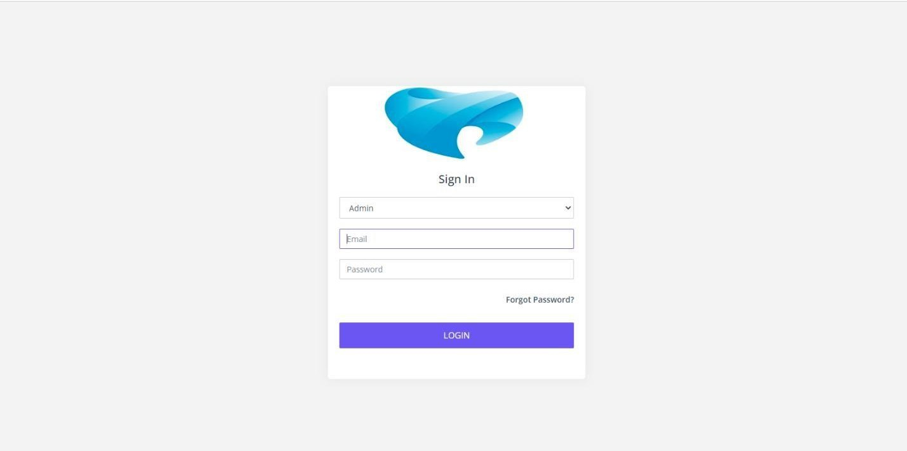
If user want to login the website he/she must be registered itself. User fill the registration form then display a message to user “Register successfully” otherwise display “Fill correctly”.

Login Page
If a user wants to shop on this online furniture shop Site he/she must be entered his/her valid Id and password.

Recent Treatment Record
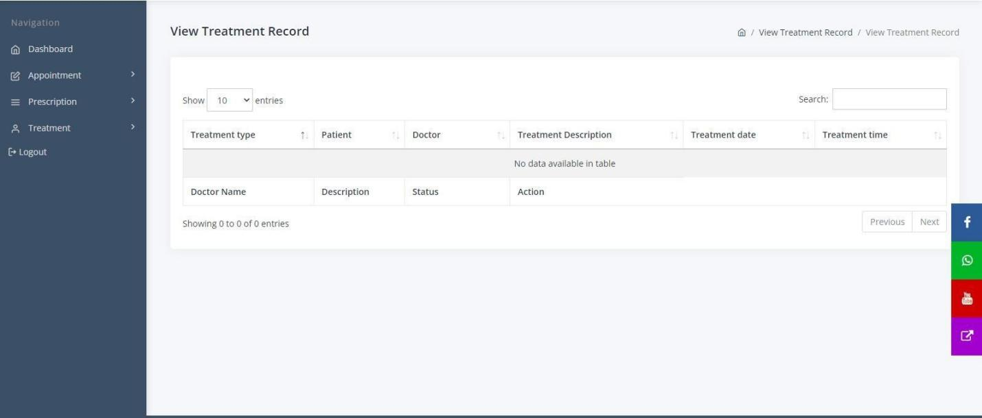
Recent record that the user gave are displayed and all detail and history of treatment record are also here.

DOCTORS
Here you can see all the doctors that are available for your services.

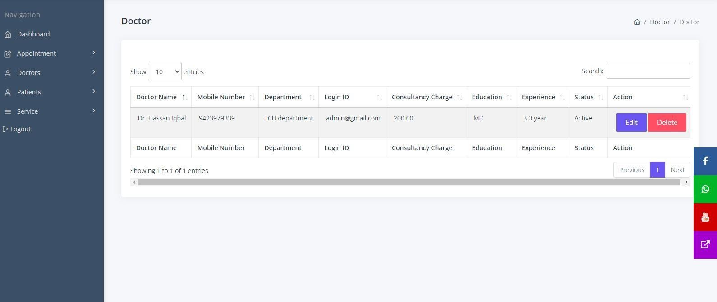
Patient List
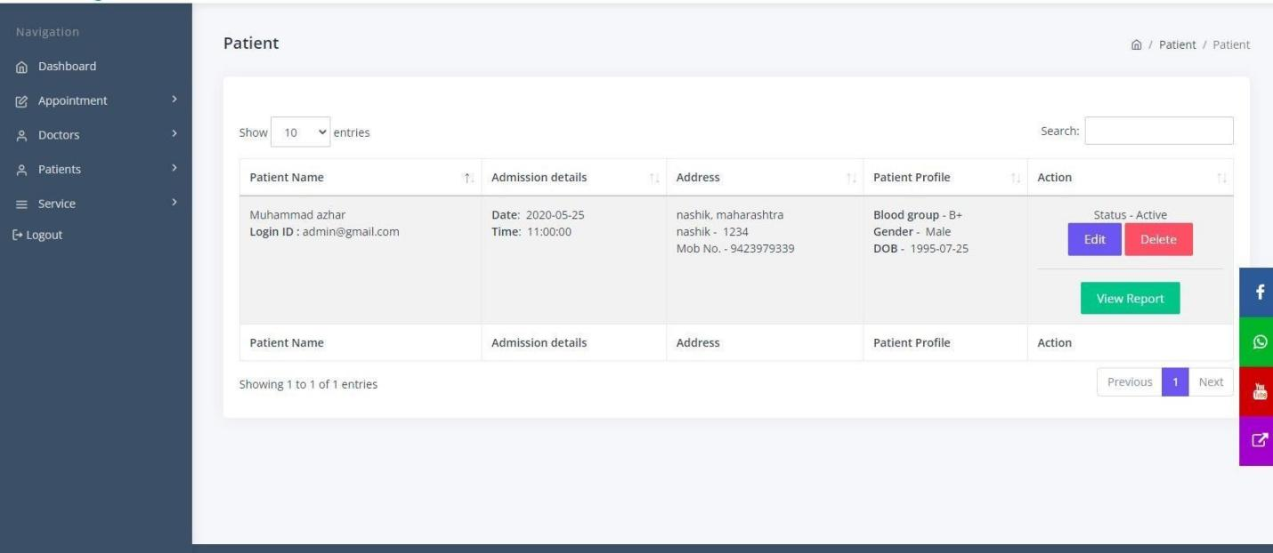
Here you can see the all the patients and its record about treatment and no of appointment.

Admin interface
Admin interface provide all option that required to admin for manage web site. By using these options admin can add, delete, update or many other functions like these.

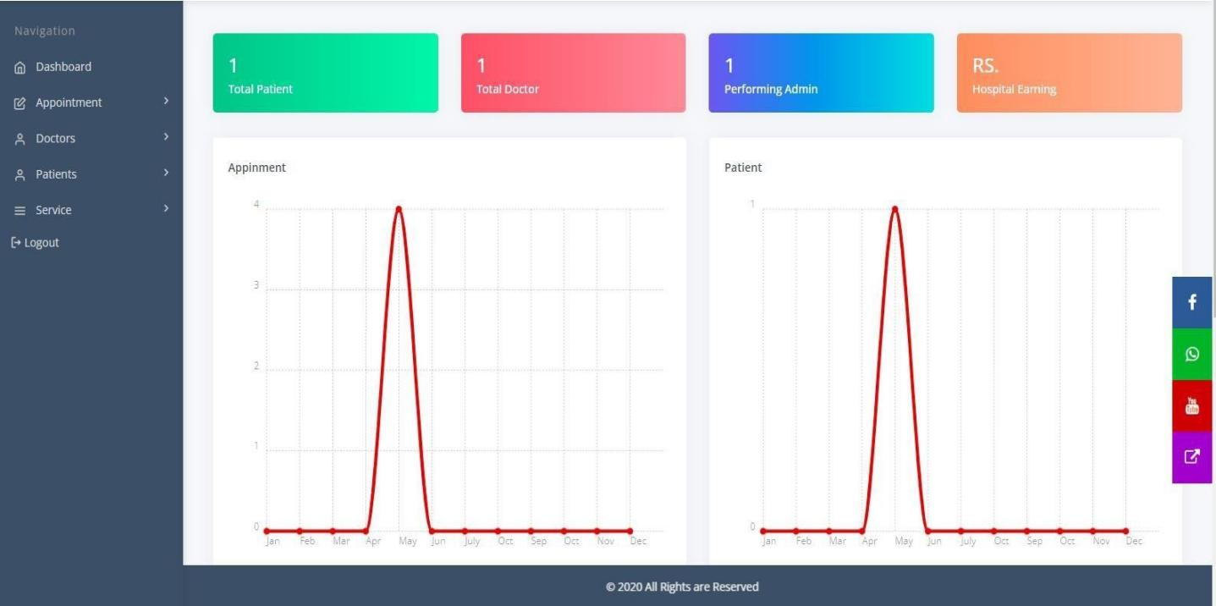

Forget password
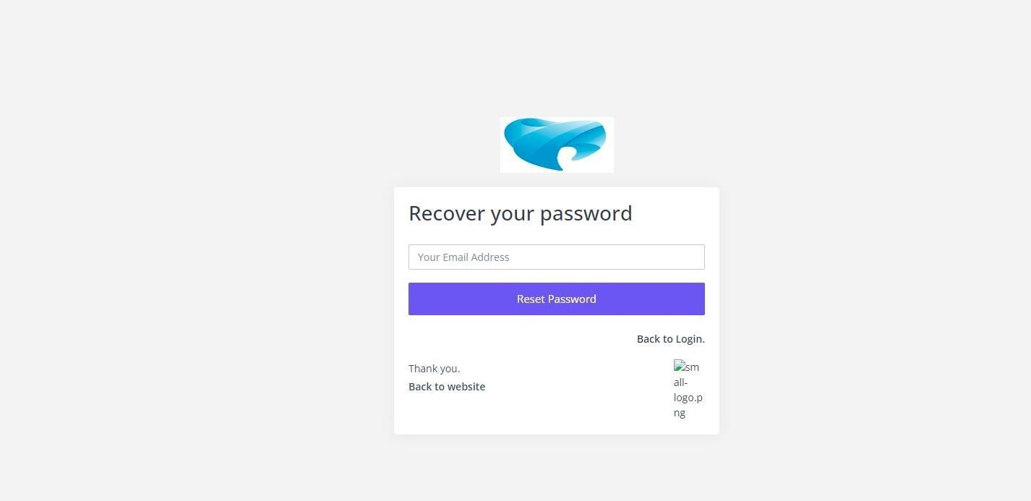
In that user interface you can also change password or recover your password if you forget it.

add new Department
In which you can add new, update and delete the department.

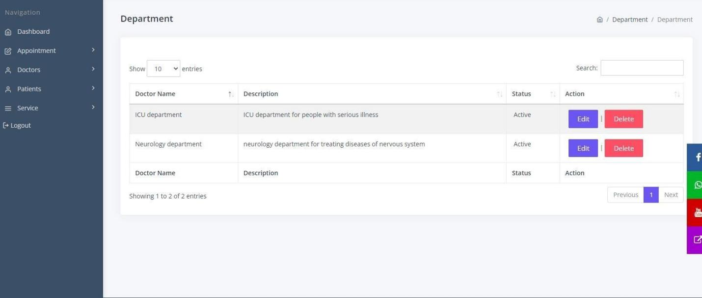
REQUIREMENTS MATRIX
Components: Use Case: | Login | Registration |  | View Categories and items |  | Checkout Items |  | Place Order | Purchase Items | Edit Shopping Cart |  | Payment
UC1 | X
UC2 |  | X
UC3 |  |  |  | X
UC4 |  |  |  |  |  | X
UC5 |  |  |  |  |  |  |  | X
UC6 |  |  |  |  |  |  |  |  | X
UC7 |  |  |  |  |  |  |  |  |  | X
UC8 |  |  |  |  |  |  |  |  |  |  |  | X
Components: Use Case: | Delete Products |  | Search Products |  | Add Product |  | Contact Us |  | Feedback |  | Logout
UC9 | X
UC10 |  |  | X
CUC11 |  |  |  |  | X
UC12 |  |  |  |  |  |  | X

UC13 |  |  |  |  | X
UC14 |  |  |  |  |  | X

APPENDICES
This section is optional.
Appendices may be included, either directly or by reference, to provide supporting details that could aid in the understanding of the Software Design Document.

